**AMAZON S3 ADVANCED FEATUEURES**

**Moving data between storage classes.**

We can transition the objects from one storage class to the other on the basis of your need.

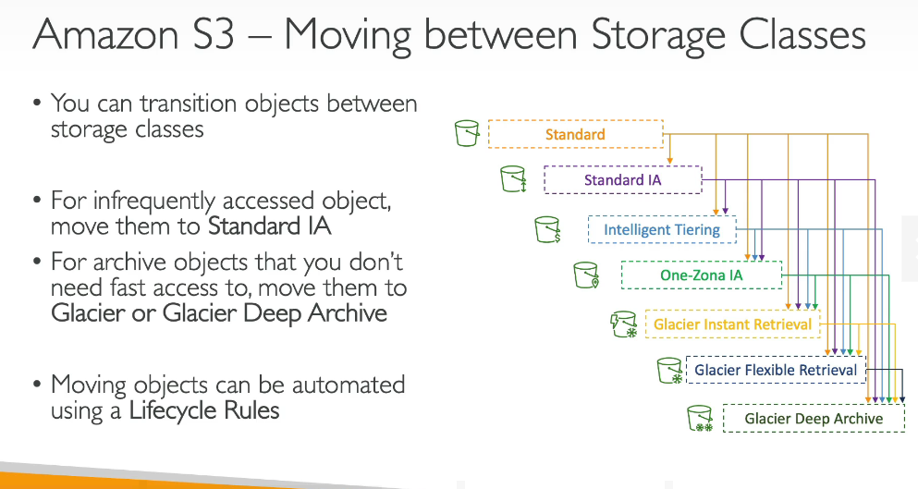

**LIFECYCLE RULES**

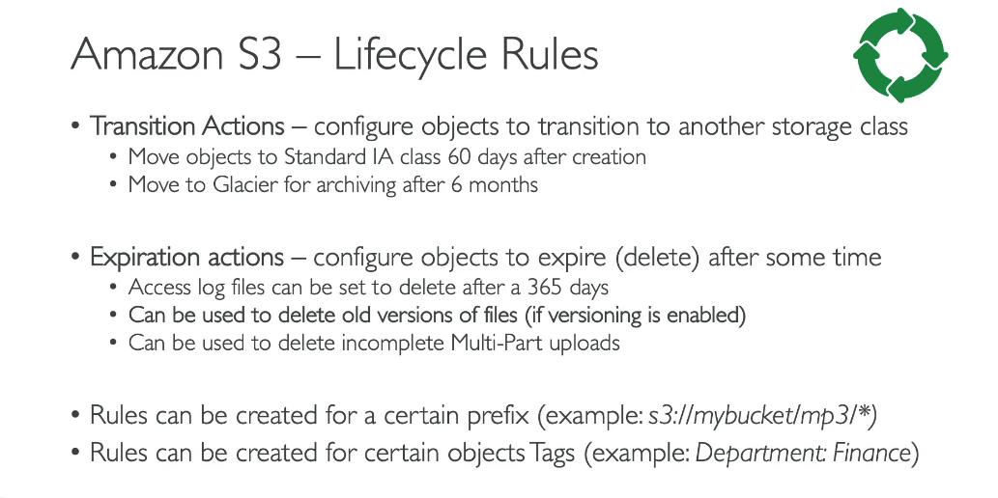

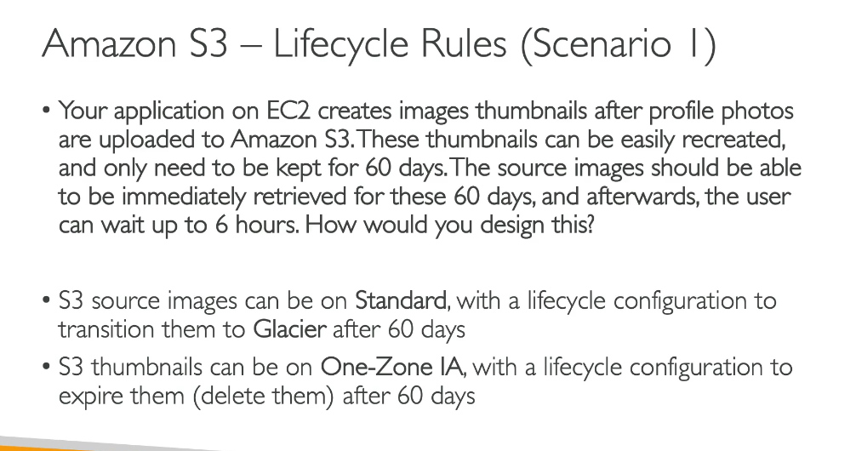

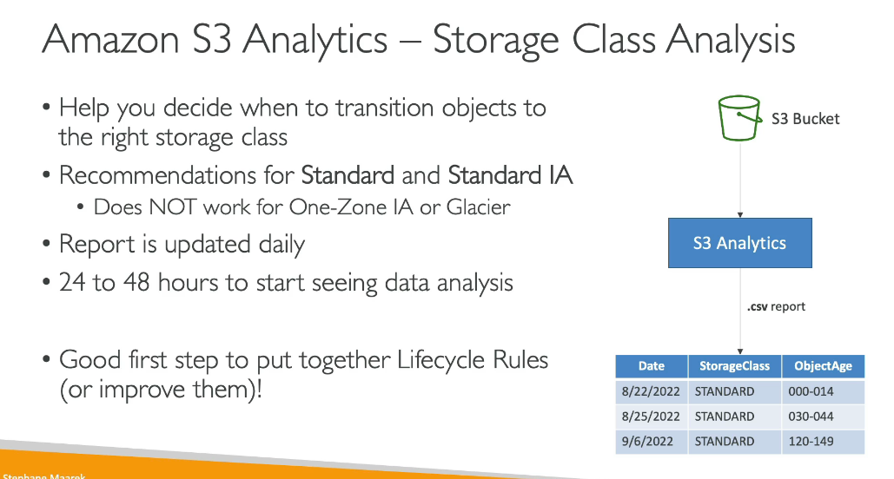

**CREATING ALIFECYCLE RULE**

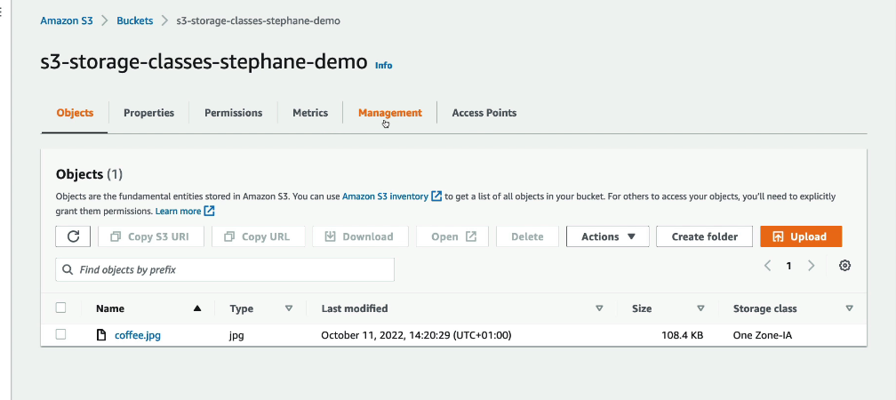

First for your bucket you need to go to the management side.

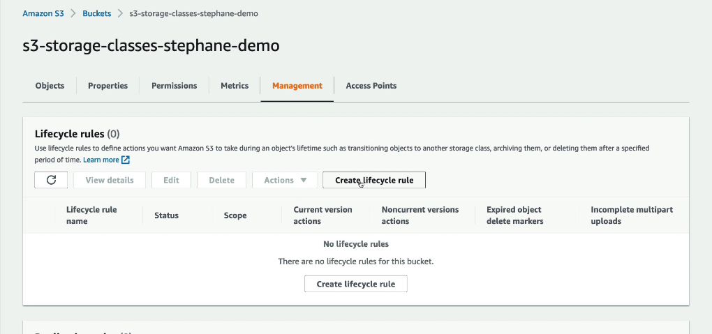

**S3 EVENT NOTIFICATIONS**

An event notification is to be created when en event is created.Aa event can be objectcreation,objectremoved,objectrestore,replication etc.

We can filter these events by saying that we only want objects with .jpg

Use case:

Would be to automatically react to an event happening in amazon s3.

Suppose to generate the thumbnail of imags uploaded to s3.

You can create as3 event n event notification and can send it to the sns,sqs or lambda function.

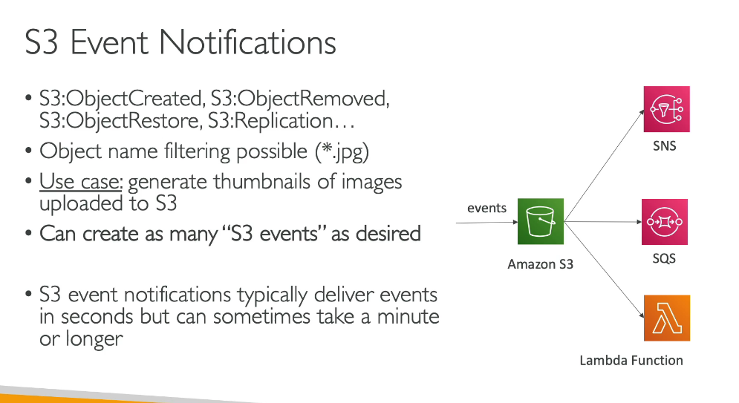

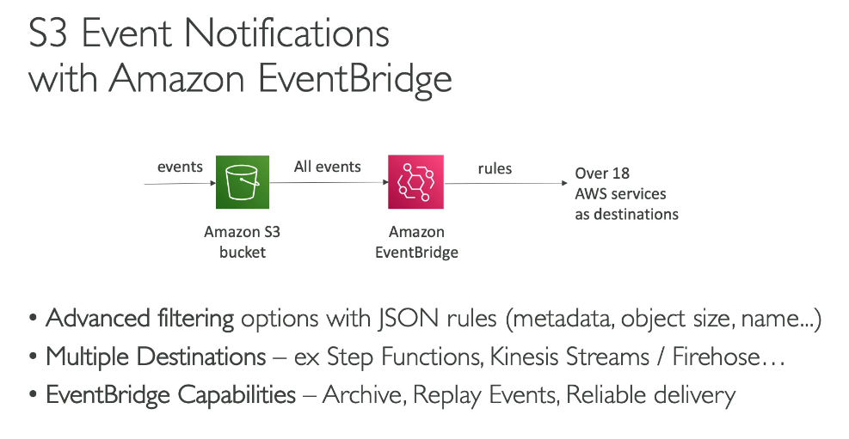

**HANDS ON**

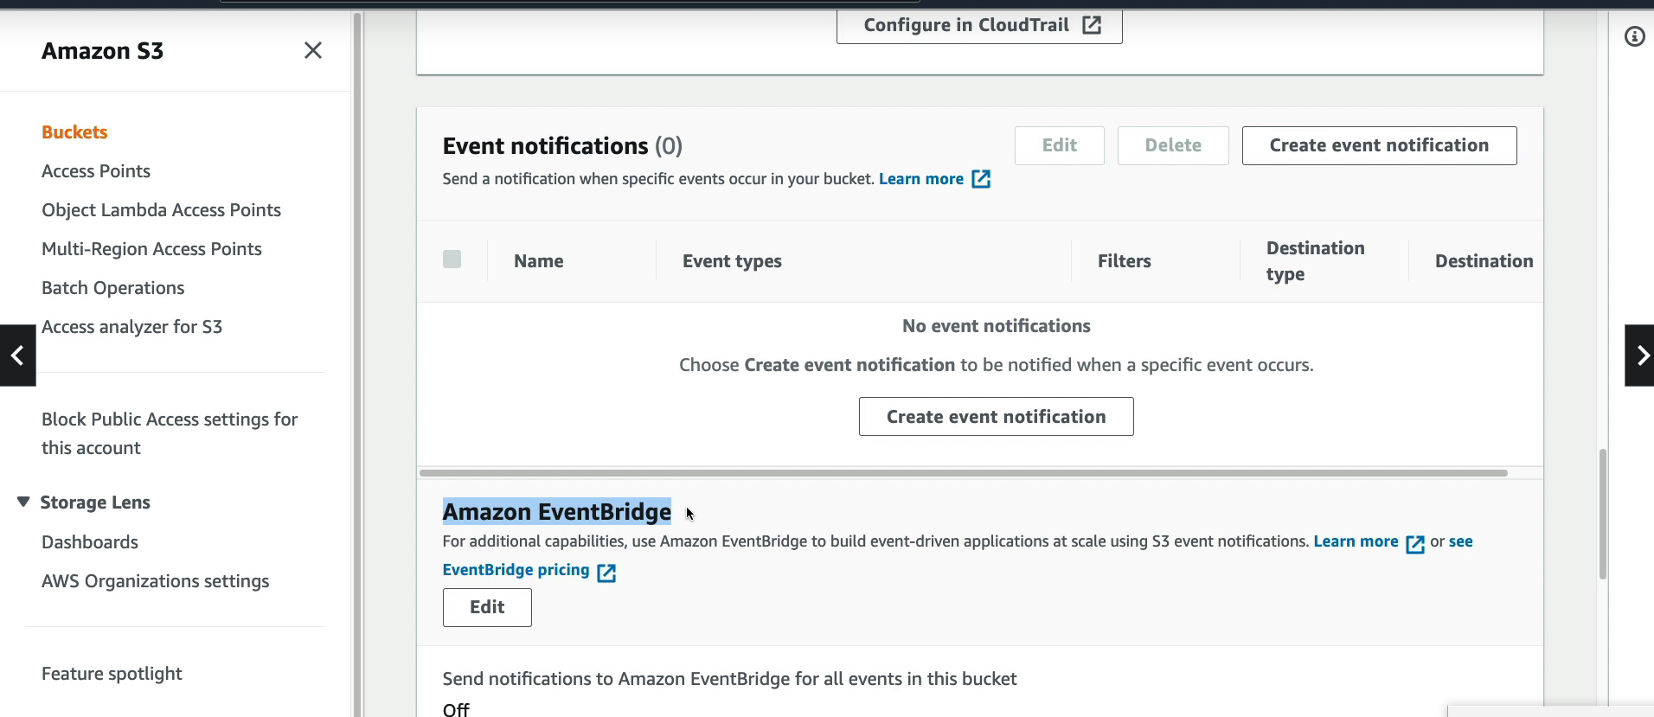

we need to enable either an event notification or an amazon event bridge in order to trigger events for this bucket.

Below we are creatinga n event notification and send event to an sqs.

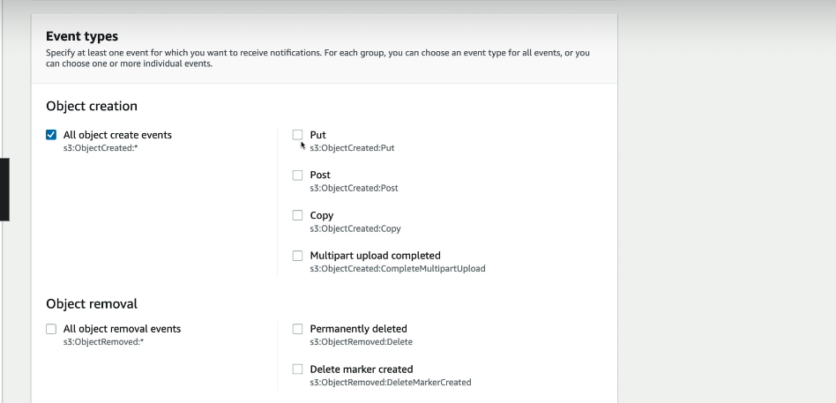

We need to choose an event tupe to make sure every time an object is created an event is going to be created.

3.Then we need to publish a destination where we want our event notification to be sent to.

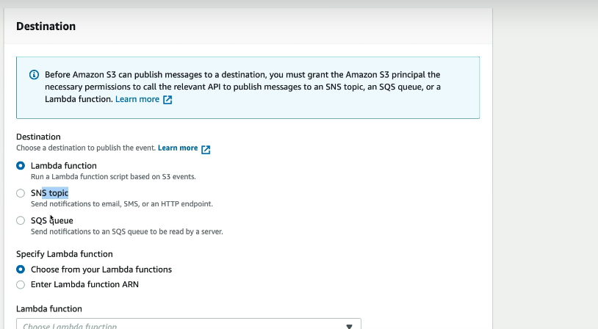

**S3 PERFORMANCE**

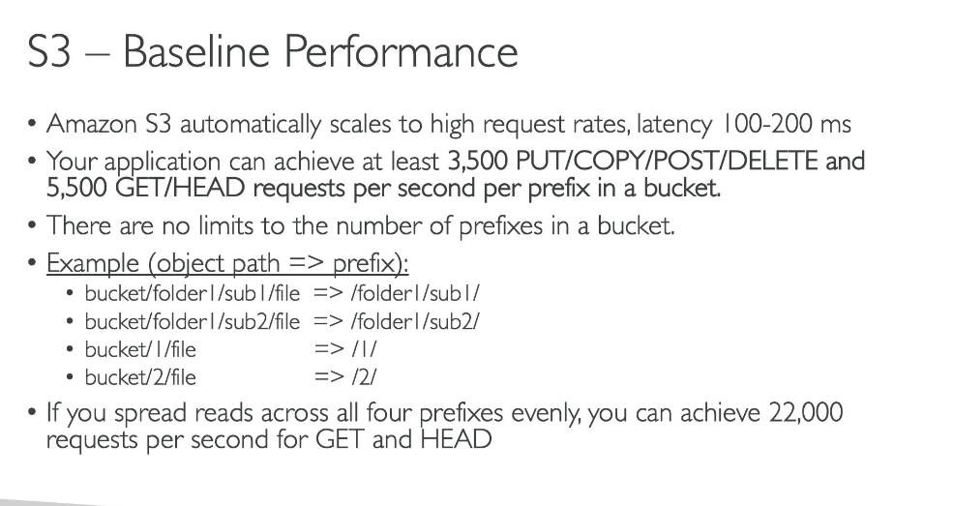

**S3 multipart upload**

In this a big file is divided into smaller chunks an dthen it is uploaded into an s3 bucket where all the parts are collected to form a bigger file.

Thus parallel processing is used here as can be seen in the diagram below.

**S3 TRANSFER ACCELERATION**

In this suppose we have some files to be uploaded to we will put those files in an edge location which will forward the data to s3 bucket in the target region.

It is compatible with multi part upload.

It has a benefit that data transfers happens over a private network.

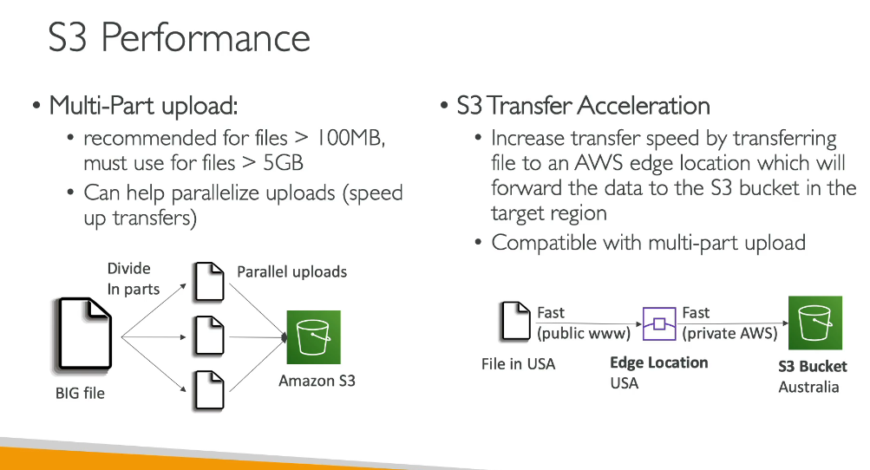

DOING GETV OPERATION

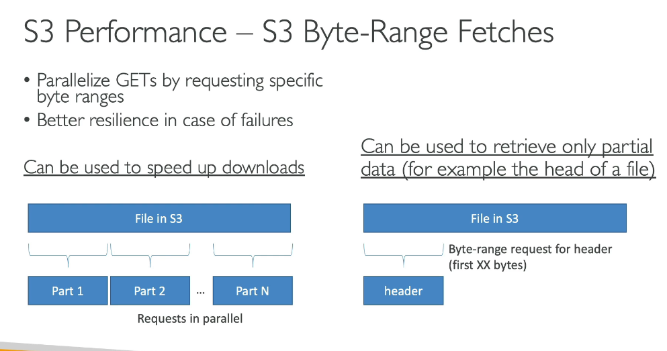

S3 SELECT AND GLACIER SELECT

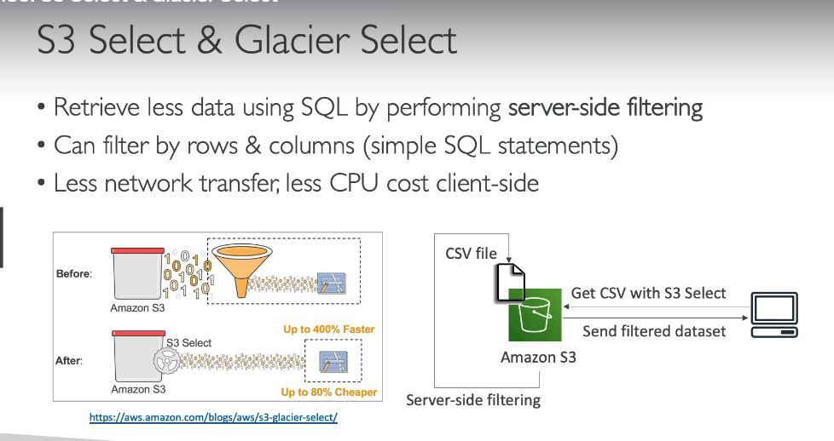

Suppose there is a need that we want to get some filtered data then what we do is that we do some server side filtering by performing some sql queries on the server side only so that there is less cost involved in data transfer and also the data comes up 400% fatsre as it si less in size.